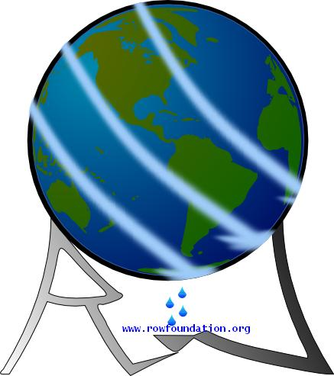
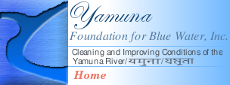

Yamuna Foundation Starts River Clean-up Campaign

Delhi Volunteers to Pick up Trash March 30
The Yamuna Foundation for Blue Water, under the umbrella of the Rivers of the World (ROW) Foundation (www.rowfoundation.org ) begins a Campaign to cleanup the Yamuna River with Volunteers picking up trash on March 30. in Delhi and March 25th in Agra. This project in India is in partnership and motivated by a similar project in Washington, DC, USA to Clean-up the Potomac River by the Alice Ferguson Foundation (www.fergusonfoundation.org ). In both cases, these major rivers are polluted in varying degrees impacting the lifeline of the people living there. Both flow through the Capitals of their countries.

Subijoy Dutta, Executive Director of the Yamuna Foundation for Blue Water announced, “We start now to clean up the Yamuna with our hands. We will continue cleanups until river becomes, once again, clean and blue. The Yamuna River is sacred. It is a life source. We can not continue to trash it!”

The United States partner in the Trash Cleanup Project is The Alice Ferguson Foundation, Accokeek, MD, USA (www.fergusonfoundation.org · www.potomaccleanup.org). On Saturday, April 5, 2008 the Foundation will lead its 20th Annual Potomac River Watershed Cleanup. Thousands of volunteers will participate at hundreds of Cleanup sites throughout the region to remove enormous amounts of trash. In the past twenty years, over 40,000 volunteers have removed more than 3 million pounds of trash from fields, forests, parking lots, shorelines, school yards, and all areas of the region that drain into the Potomac River.

“Our trash problem is one of the few major long-term issues we can address and solve right now,” said Tracy Bowen, Executive Director of the Alice Ferguson Foundation. “It is through addressing this trash issue that we can get to greater awareness of many other environmental issues, clean, healthy water, and strong civic pride... The goal of the project is to create a trash free Potomac by 2013!”

Mr Bankey Lal Maheshwari of the Sri Nathji Nishulk Jal Sewa and Coordinator of the Agra Yamuna Cleanup said a sustained mass movement was necessary. "Citizens should stop looking to the government for everything but initiate action on their own to stop further degradation of the river." (Put in name of coordinator and should correspond to the Contact information at the top).

The Yamuna River Cleanup in DELHI takes place on March 30 2008. Volunteers will meet at kotla nala (near H nizamudeen Rly station) and remove trash between 8.30am to12.30pm

Coated gloves will be given to all Volunteers to protect hands and Blue plastic bags will be used to collect recyclable items and orange bags for trash to be disposed. The recyclables will be transported to the municipal recycling center; arrangements are being made for the non-recyclables to be picked up by the city garbage collection system.

Dehli Coordinator, Mr. Suresh Nair and D.K. Mital for the Yamuna River Cleanup are committed to the Yamuna Foundations’ motto “…To turn the Yamuna Blue” and agrees that it will take a major effort on the part of all sectors of the Dehli community to turn this issue around. In a recent press conference Subijoy Dutta said “We must stop trashing the river we love that is vital to health and livability of everyone in this region. We must make this commitment NOW!”

