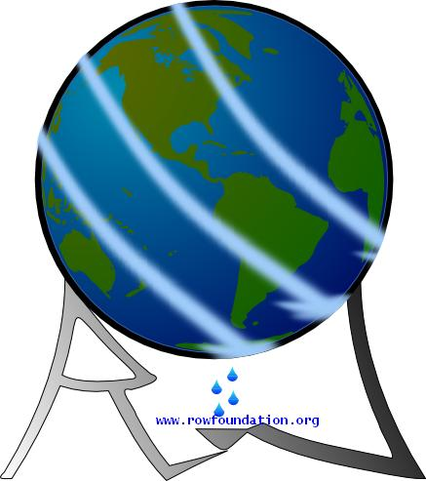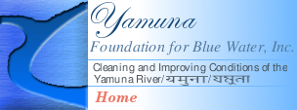

Greetings from Blue Yamuna
A Foundation Dedicated to Turn the Yamuna Water Blue
For Immediate Release March 11, 2008

Delhi Coordinator: Agra Coordinator:
Mr. Suresh Nair and D.K. Mital Brij Khandelwaal
March 29/30, 2008, Delhi, India March 25, 2008, Agra, India
Suresh: 4050-6600; Mobile: 98990-12403; Brij: 400-2937; Mobile: 99971-86708
D.K. Mital: 98105-65485
gtindia@rediffmail.com brijkhandelwal@hotmail.com

Yamuna Foundation Starts River Clean-up Campaign

Delhi and Agra Volunteers to Pick up Trash

The Yamuna Foundation for Blue Water, under the umbrella of the Rivers of the World (ROW) Foundation (www.rowfoundation.org ) begins a Campaign to cleanup the Yamuna River with Volunteers picking up trash on March 29th in Delhi and March 25th in Agra. This project in India is in partnership and motivated by a similar project in Washington, DC, USA to Clean-up the Potomac River by the Alice Ferguson Foundation (www.fergusonfoundation.org ). In both cases, these major rivers are polluted in varying degrees impacting the lifeline of the people living there. Both flow through the Capitals of their countries.

Subijoy Dutta, Executive Director of the Yamuna Foundation for Blue Water announced, “We start now to clean up the Yamuna with our hands. We will continue cleanups until river becomes, once again, clean and blue. The Yamuna River is sacred. It is a life source. We can not continue to trash it!”

The United States partner in the Trash Cleanup Project is The Alice Ferguson Foundation, Accokeek, MD, USA (www.fergusonfoundation.org · www.potomaccleanup.org). On Saturday, April 5, 2008 the Foundation will lead its 20th Annual Potomac River Watershed Cleanup. Thousands of volunteers will participate at hundreds of Cleanup sites throughout the region to remove enormous amounts of trash. In the past twenty years, over 40,000 volunteers have removed more than 3 million pounds of trash from fields, forests, parking lots, shorelines, school yards, and all areas of the region that drain into the Potomac River.

“Our trash problem is one of the few major long-term issues we can address and solve right now,” said Tracy Bowen, Executive Director of the Alice Ferguson Foundation. “It is through addressing this trash issue that we can get to greater awareness of many other environmental issues, clean, healthy water, and strong civic pride... The goal of the project is to create a trash free Potomac by 2013!”

Mr Brij Khandelwal, Coordinator of the Agra Yamuna Cleanup said a sustained mass movement was necessary. "Citizens should stop looking to the government for everything but initiate action on their own to stop further degradation of the river."

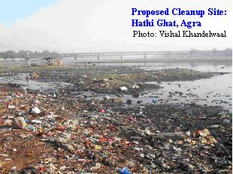
The Yamuna River Cleanup in Agra takes place on March 25, 2008. Volunteers will meet at _Hathi Ghat, Yamuna Kinara road and remove trash from the river bank between 8am to 12 noon.

Coated gloves will be given to all Volunteers to protect hands and Blue plastic bags will be used to collect recyclable items and orange bags for trash to be disposed. The recyclables will be transported to the municipal recycling center; arrangements are being made for the non-recyclables to be picked up by the city garbage collection system.

Delhi Coordinator, Mr. Suresh Nair and D.K. Mital for the Yamuna River Cleanup are committed to the Yamuna Foundations’ motto “…to turn the Yamuna Blue” and agrees that it will take a major effort on the part of all sectors of the Delhi community to turn this issue around. In a recent press conference Subijoy Dutta said “We must stop trashing the river we love that is vital to health and livability of everyone in this region. We must make this commitment NOW!”

As in Agra, similar gloves and bags will be used. The recyclables will be transported to the municipal recycling center; arrangements are being made for the non-recyclables to be picked up by the city garbage collection system.

After the Trash Cleanups, information, along with pictures, will be released publicly about how much volume/weight and types (paper, plastics, soda cans, bulk items, such as tires etc.) of trash collected. Both ROW Foundation and Alice Fergusion Foundation will have listing of volunteers and pictures from the Cleanups on the websites, which will be easily accessible to everyone.

