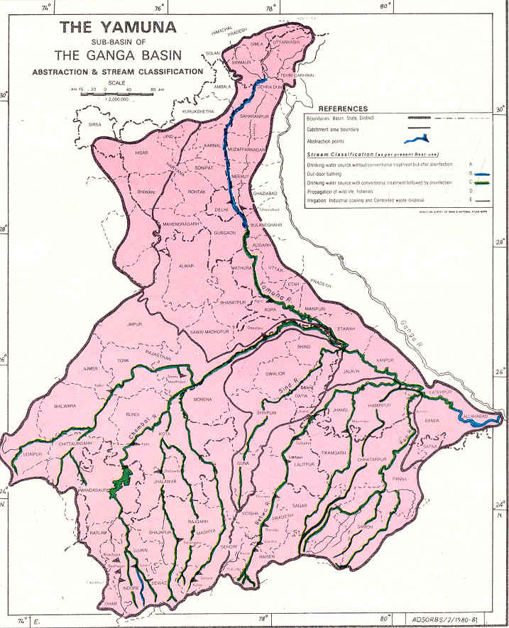
Yamuna Conference 2008 (updated- Dec 29, 2007)
- Cleanup Options & Strategies

Sponsored by: Yamuna Foundation for Blue Water,
(http://www.rowfoundation.org )
Rivers of the World Foundation
(http://www.rowfoundation.org )
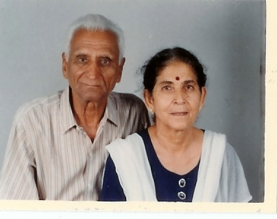
Mr. & Mrs. Manohar Lal & Leela Chaudhry
See Our New!!! Website


Location:
New!!! Location!!

Sri Aurobindo Society, New Mehrauli Road, Adchini
New Delhi Ph: 91-011-26561986/ 2652 9022 (Extn: 33, 35)
Date/Time: Friday, January 11, 2008/ 10:00 – 5:00 PM

Please Complete and e-mail or Mail the Registration Form below to:
Mr. Girish Chaudhry  e-mail: leelaworld@vsnl.com  or to Subijoy Dutta  e-mail: blueyamuna@yahoo.com | Or send by Postal Mail to:  Mr. Girish Chaudhry, Attn: Yamuna Registration  Yamuna Foundation for Blue Water  M-57B, Lower Ground Floor  Malviya Nagar , New Delhi-110017; Ph: 98115-29898
:

REGISTRATION FOR THE YAMUNA CONFERENCE, January 11, 2005

Name: ___________________________; Position___________________________________________

Company/Organization__________________________________________________________________

Address______________________________________________________________________________

Phone:______________________________; E-mail: __________________________________________

Registration Fees: Active Participation…No Fees ;
Absentee Participation - Unable to participate in 2008, possibly participate in 2009 (To be sponsored
by Engineering Conference International (www.engconfintl.org )
Any Other Support -
Specify –

