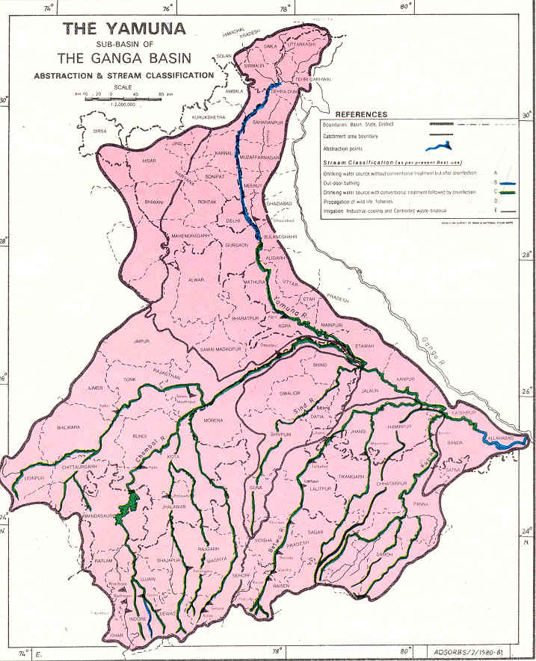
Yamuna Conference 2008 (updated- Jan 10, 2007)
- Cleanup Options & Strategies

Sponsored by: Yamuna Foundation for Blue Water,
(http://www.rowfoundation.org )
Rivers of the World Foundation
(http://www.rowfoundation.org )
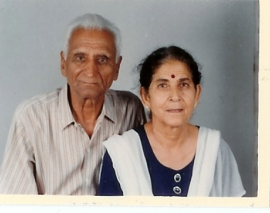
Mr. & Mrs. Manohar Lal & Leela Chaudhry



Location:
New!!! Location!!

Sri Aurobindo Society, New Mehrauli Road, Adchini
New Delhi Ph: 91-011-26561986/ 2652 9022 (Extn: 33, 35)
Date/Time: Friday, January 11, 2008/ 10:00 – 5:00 PM

Purpose and Objective:

Strategies to mitigate pollution of the rivers Ganga and Yamuna have been developed and implemented for over two decades. Central and State Governments, international aid agencies, research and educational institutions, corporate groups, NGOs and other civil society groups have been involved in various cleanup initiatives and outreach. However, the challenge of ever-increasing pollution in these rivers is yet to be met. To explore possible ways to meet this challenge, this conference is planned as a forum for NGOs, Governmental Agencies, State, Local and Central, and other Stakeholders/concerned Citizens, and above all the direct users of Yamuna Water to voice their views and step forward to join hands in this massive effort. The remedial technology options befitting the local conditions of the stretches of Yamuna river close to major metropolitan cities, such as, Delhi, Mathura, and Agra will be the focal point of discussion amongst participants involved in this discussion/forum. All of the participants are expected to take an active role and come forward to join hands at this conference to review and share their experience on the various efforts that they have undertaken so far and their “lessons learnt”. This will also be a forum for the State, Local, or Central Governmental Agencies to discuss any of their current or impending actions involving the water quality protection of rivers and streams.

The main objective of this conference is to yield a plan identifying viable remedial options and strategies for the Yamuna river and to draw a parallel for any other Rivers in India or the World. Based on the feasibility of various remediation options it is hoped that the Conference will feed fresh inputs into the existing Action Plans for Yamuna, Ganga or other Rivers of India. The outcome of the conference is expected to have conspicuous options, which should lead us to expeditious implementation steps. The strategies budding out of this conference should lead us to a short- and long-term cleanup plan. Efforts will be made to resort to a bottom-up approach rather than a top-down one to help these twin sisters, the major life-supporting arteries of Delhi, Agra, and many other cities in India.

We invite you to participate in the conference and to join hands in developing a viable and multifaceted plan involving cleanup, awareness, education, and improved watershed management that will turn the waters of these great and holy rivers blue someday. This conference is also a stepping stone for an International Conference planned in 2009 in New Delhi under the sponsorship of Engineering Conferences International (ECI) (www.engconfintl.org ).

Tentative program

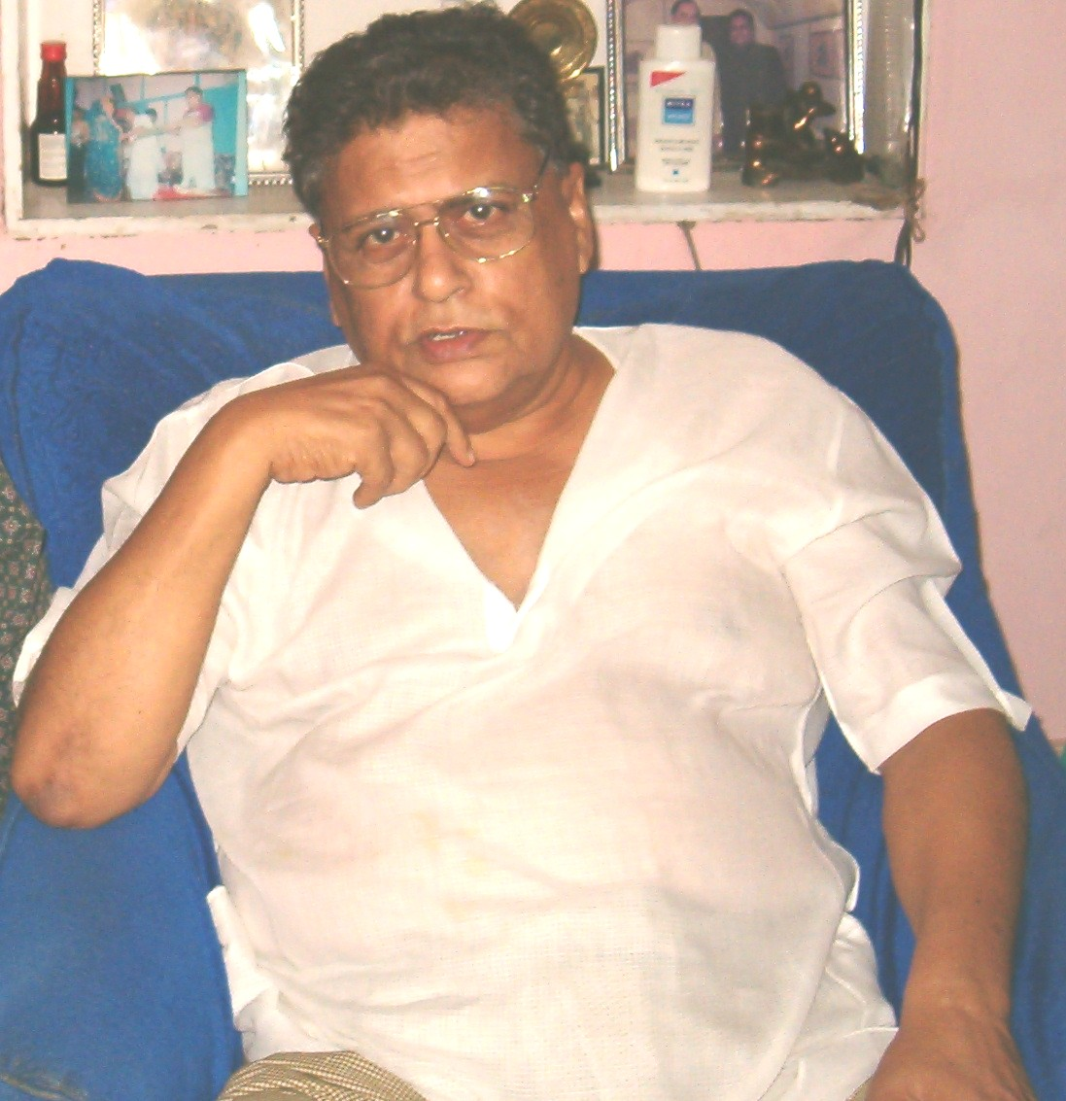
Opening Remarks (30 Mins) - Santosh Mohan Dev (Confirmed)– Cabinet Minister for Heavy Industries and Public Enterprises
- Mrs. Sheila Dixit, (Invited)

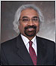
- Mr. Sam Pitroda/Representative, (Initiated the Conference -invited) Chairman of WorldTel Ltd.

Presentations (15 Mins each)

Status of Yamuna River - Dr. R.C. Trivedi, Additional Director, CPCB
Yamuna River Issues & Problems - Mr. Suresh Babu, Center for Science and Environment
Yamuna River Issues & Awareness - Dr. Mrs. K. Vijaya Lakshmi & Usha Srinivasan, Development Alternatives, (www.devalt.org)
Yamuna Floodplain Restoration - S. Dutta (Dennis Haag -Schedule Conflict – will provide
Summary) Burns & McDonnell, (www.burnsmcd.com Kansas
City, MO

Productive Use of Solid Waste - Gary Huffman, Chief Technical Officer, Enviroproducts, International,
Yamuna remediation effort and status - Subijoy Dutta, P.E., Yamuna Foundation for Blue Water
Step 2 – International Conference - Gary Huffman (representing ECI), On Impacts of Developments and Remediation Options, 2009, New Delhi (www.engconfintl.org ), NY
Lunch - 1:00 – 2:00 PM
Each Presentation will be followed by 5 Minutes of Listing/Identifying Questions and Issues for Discussion

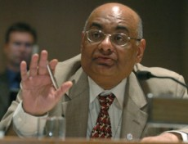
Lunch + Other Breaks will be shown in the final detail Agenda

Panel Discussion/Action Session (90+ mins):
Remediation Options and Strategies:
- Discuss Listed Questions and Issues (Gourisankar Ghosh)
- What Strategies Exist and What Others Could be Considered
- Task Breakdown and Responsibilities
- RWH (Rainwater Harvesting) – Lead by Ram Krishnan
- Cloud Seeding and Artificial Rainfall – Lead by I.V. Murali Krishna, JNTU, Hyderabad
- Next Step

Refreshments

For further information please contact Mr. Girish Chaudhry, Phone: 4604-9161 or 98115-29898, email: leelaworld@vsnl.com or Mr. D.K. Mital, Ph: 2274-2512 in New Delhi.

Please Complete and Mail the Registration Form below to:
Mr. Girish Chaudhry  e-mail: leelaworld@vsnl.com  or to Subijoy Dutta  e-mail: blueyamuna@yahoo.com | Or send by Postal Mail to:  Mr. Girish Chaudhry  Attn: Yamuna Registration  Yamuna Foundation for Blue Water  M-57B, Lower Ground Floor  Malviya Nagar , New Delhi-110017  Ph: 98115-29898
:


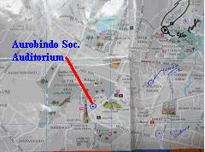
JNU
QUTAB
HOTEL

IIT
Saket
NCERT
NCERT
AIIMS
Aurobindo Marg
Adhchini
Sri Aurobindo
Ashram
New Mehrauli Road
Airport
Vasant Kunj
Sri Aurobindo Society
Society
Ring Road

Directions and LOCATION OF Yamuna Conference 2008

Cut Here

REGISTRATION FOR THE YAMUNA CONFERENCE, January 11, 2005

Name: ___________________________; Position___________________________________________

Company/Organization__________________________________________________________________

Address______________________________________________________________________________

Phone:______________________________; E-mail: __________________________________________

Registration Fees: Active Participation…No Fees

Absentee Participation - Unable to participate in 2008, possibly participate in 2009 (To be sponsored by Engineering Conference International (www.engconfintl.org )
Any Other Support -
Specify –

