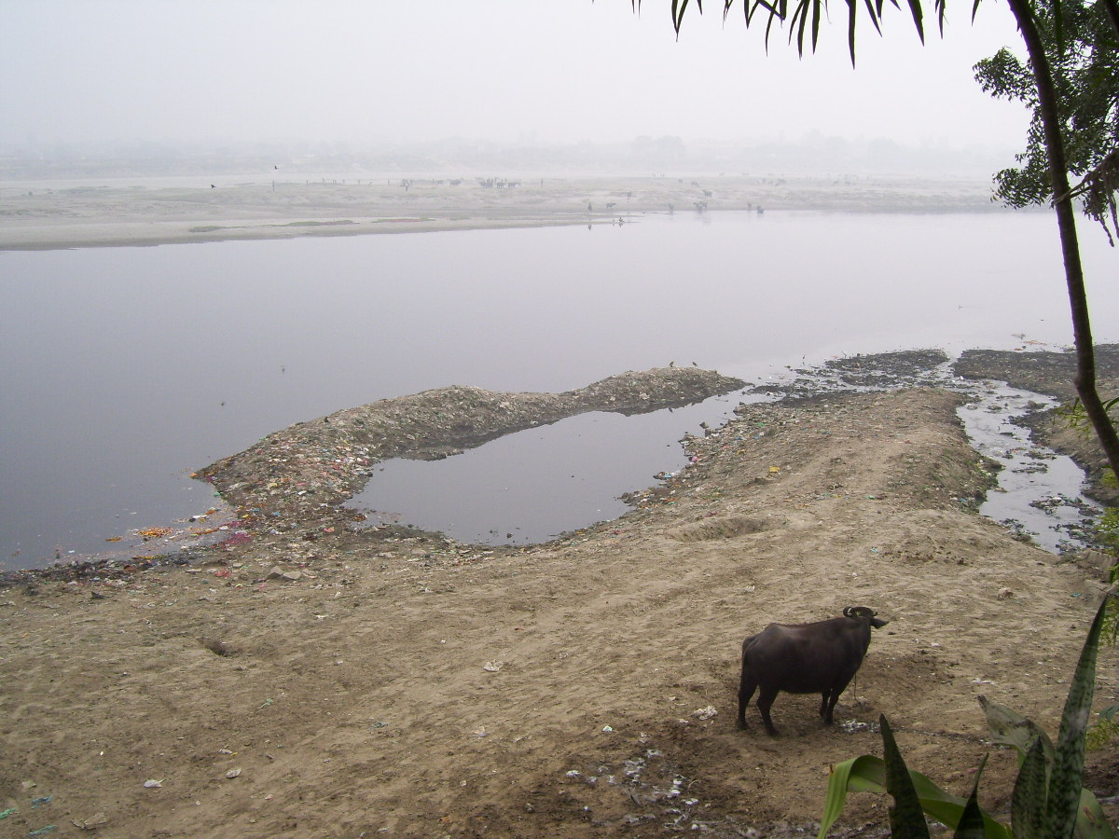
VRINDAVAN-MATHURA-AGRA YAMUNA CONFERENCE, January 4, 2009
Summary of the conference
AGRA
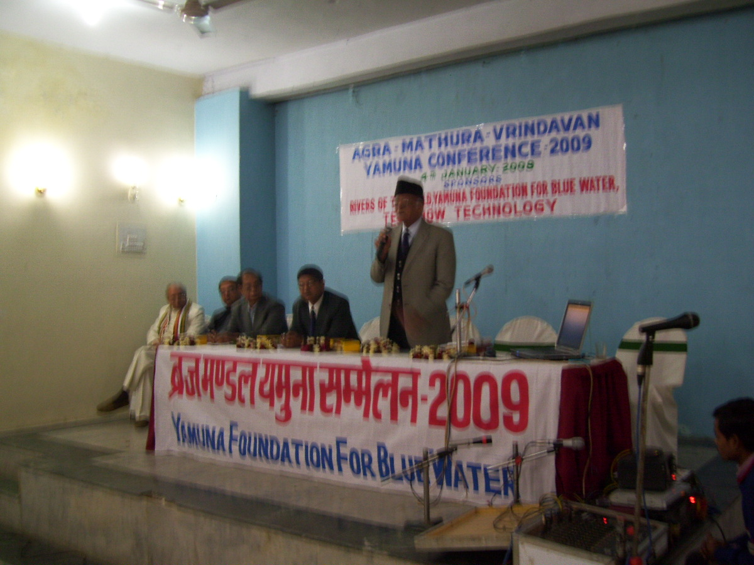
A conference of people's representatives, NGOs, activists and pollution experts from Agra, Mathura, Firozabad, Hathras and Vrindavan that ended late Sunday evening, demanded heritage status for the river Yamuna.
Cry of the Yamuna at the Balkeswar Ghat, Agra
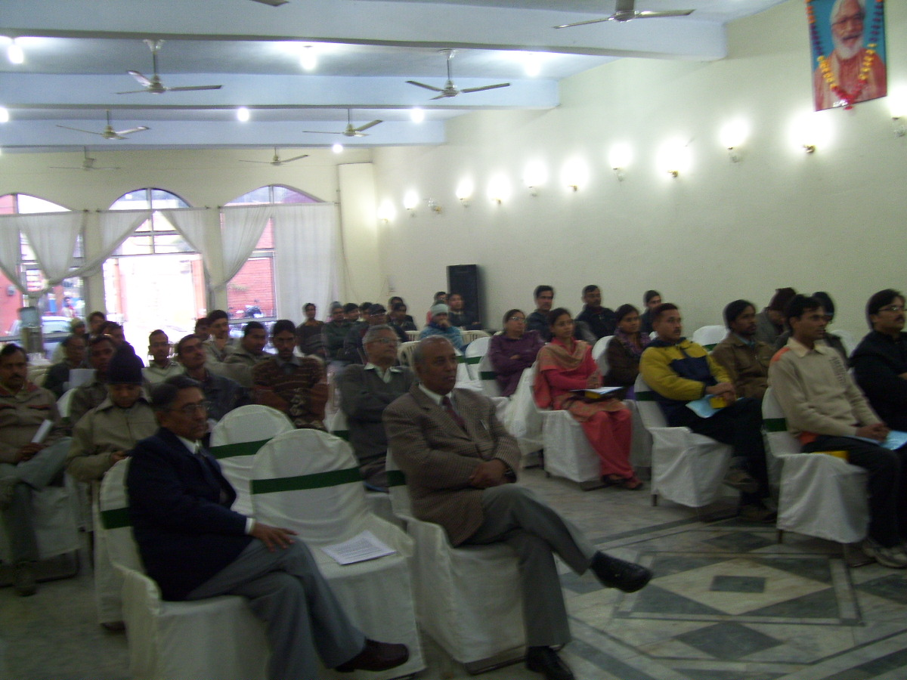
Brij Khandelwal facilitated the conference and mentioned that in a resolution passed unanimously the central government was asked to constitute a Yamuna Authority "to take over all the cleaning and remedial measures from the ineffective Jal Nigam of UP which after so many action plans and spending almost a thousand crores has failed to show any tangible results."
Dr. Pareek speaking at the Conference
Organised by Rivers of the World Foundation and Yamuna Foundation for Blue Water, the conference was inaugurated by renowned Homeopath Dr RS Pareek who in his opening remarks called for greater involvement of the local population in saving a natural asset on which the life and health of millions of people depended.
Subijoy Dutta, environmental scientist from Maryland said "river cleaning can be done through use of technology like diffusers, aerators, and training the students to monitor river water quality at regular intervals. Subijoy said he was shocked to find from his survey that the open drains "in Mathura, Vrindavan and Agra were still discharging large quantities of untreated waste water directly and there was no governmental control."
Participants at the conference
Ram Koduri, who worked with the Chicago sanitation and water-waterways system as consultant said there was need to change the cultural habits and the mindsets of the people. The rivers are valuable assets and not sewer lines. Drastic measures should be taken to ensure that there was no further pollution of rivers in the country, Koduri said.
Vrindavan's Braj Rakshak Dal representative talked of how they had been able to bring about discernible changes in the Braj Mandal. "Government agencies were now responding and the local people too had begun to get involved. Yamuna is not just a supplier of water but also a goddess worshipped by millions of Vaishanavites round the year. It was therefore necessary to involve the pilgrims and the babas and saints of the area to sensitise the people," Mittal, an alumunus of IIT Kharagpur said.
Braj Mandal Heritage Conservation Society president Surendra Sharma called for fixing the share of downstream cities in the water of the Yamuna. "Right now all the water of Yamuna is barraged in Delhi. What Mathura and Agra get is waste and sewer from Delhi and Haryana. Agra's share of water should be fixed and come directly to us. A political movement will have to be launched for this," Sharma said.
Dr Nawal Sharma, a scientist working on polymers for organ transplantation, in Texas, wanted citizens of Agra to become little more serious and concerned about the level of dirt, garbage and filth all around. "They are callously polluting the river by dumping all the waste. Children should be taught not to litter around and throw garbage just any where. Municipal bodies should also be alive to these problems and show a little more urgency and commitment. India lacks nothing but will power and dedication," Sharma told the conference.
The conference decided to set up an Awareness Centre in Agra and start a river trash cleaning programme in early March.
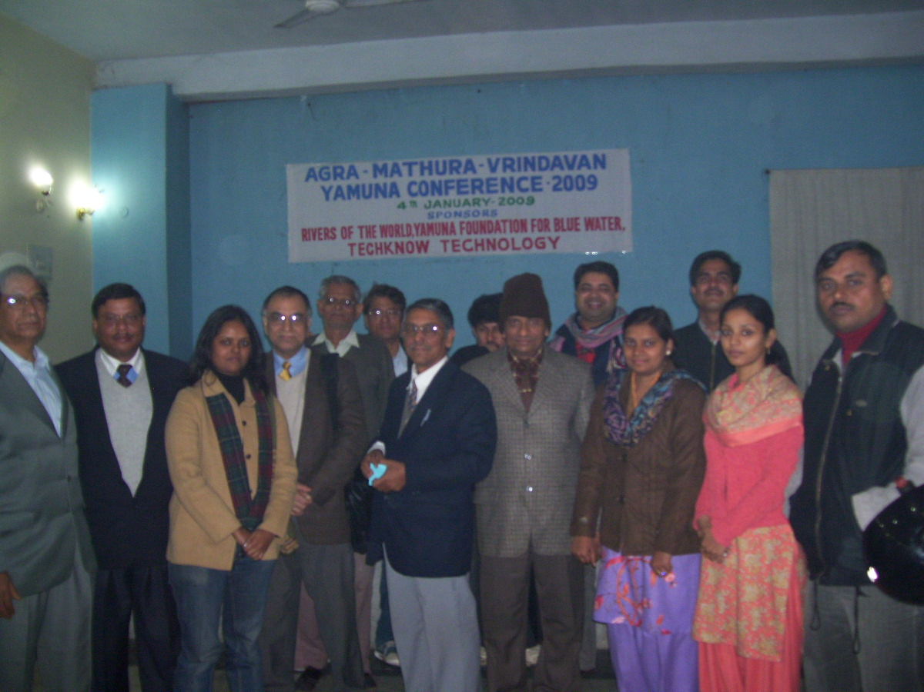
The conference was attended by a large number of local activists, students, researchers, as well as activists from Delhi including members of Water Community, India Portal.
Some prominent participants: Ravi Singh, Dr RP Singh, Major Shahni, Acharya Jaimini from Vrindavan, Dr Deepankar Saha of the Central Pollution Control alongwith his assistant, Dr Rajan Kishore, Dr Sanjay Chaturvedi, Sanmay Prakash, Rajeev Saxena, Vishal Dwivedi of Sankalp, volunteers of Braj Rakshak Dal, Manohar Gidwani, president of the Agra Cartoon Forum, Dr VP Singh, Surendra Sharma, Sudhir Gupta, Vaibhav Chibber of Itisha, Megh Singh Yadav of Agra Human Rights Forum, Naresh Paras of Amnesty International, Mahesh Dhakar, Anil Arora of Sangharsh, Rajesh Dixit of Jagta Shahar, Mahesh Shukla, ex-MLC Anurag Shukla, a large number of media persons, theatre personalities and artists. Some of the participants are shown in the picture on the right.
Based upon the input from the participants the action items developed by the ROW foundation for implementing in 2009 are listed below:
- Project plan and development of the Aeration System Installations
- Setting up a Yamuna Awareness Center in Agra
- Water Quality Monitoring by Youth Group
- Trash Cleanup and Site Restoration
ROW foundation hopes that local people will join hands in cleanup, awareness, and improved watershed- management for the Yamuna river in Agra area which should help turn the waters of this great and holy river blue someday.

