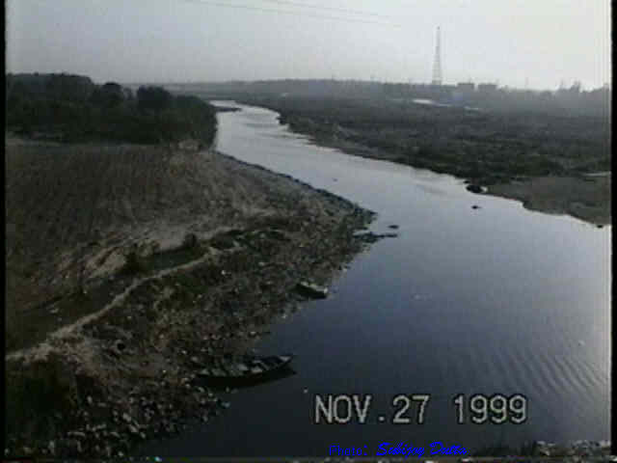
Yamuna River – Yours or Mine ?
A SEMINAR……….
WITH AN EXCLUSIVE PANEL OF OBSERVERS
From the Yamuna Foundation for Blue Water (http://www.rowfoundation.org/row/)
DATE: September 3, 2008, from 11:15 AM - 12:15 PM

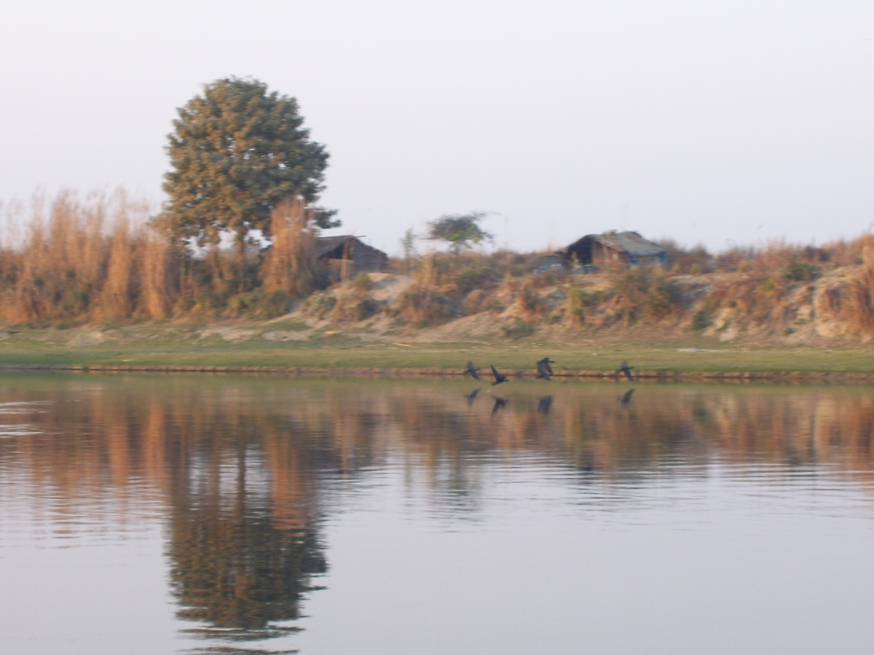
LOCATION: Gargi College,
University of Delhi, Siri Fort Road, Delhi -110049, India, Phone No.26494544
Fax No.011-26494215
- Discussion Topics
  - Brief Introduction of Participants and Panel
  - Yamuna River - Background
  - Participants View (Casual information)
  - Expert Panel Interaction
  - Possible Steps and ideas – Monica Das
  - Additional thoughts – Brij Khandelwaal
  - Press Coverage and Photographs
  - Wrap Up
  - Refreshments

- For More Information contact:
- Dr. Monica Das , E-mail: dasmonica@gmail.com
- Register for the Event by completing the form below
REGISTRATION FORM
Please e-mail form to Blueyamuna@yahoo.com

Name:

Affiliation:

Address:

Phone/Fax No.

e-mail address:

Remarks(Area of Interest – Water Quality Monitoring, Tree Planting etc.)

