ROW Foundation Announces World Water Day 2016 Program
In Collaboration with United Nations Environment programme (UNEP)
Events take place during March 22-27, 2016 as mentioned below. March 12, 2016
BANNERS & LOGOS
ROW Foundation Announces Cash Awards for WWD2016–

- Best Event (US $150.00); | - Best Event Coverage/Reporting ($100.00);
- Best Children/School Participation ($100.00) | - Most Sustainable Activity ($100.00)
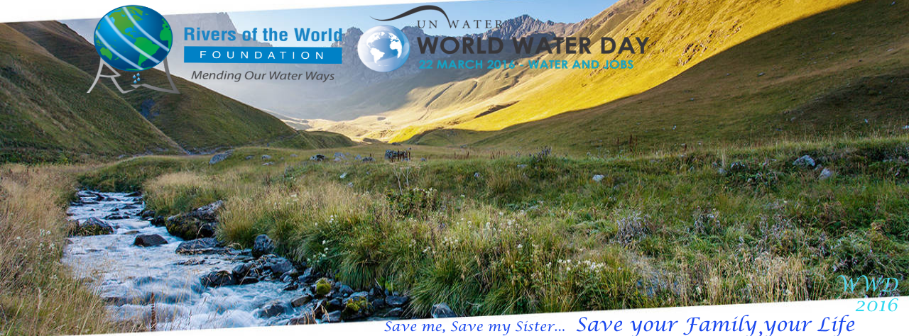
USE THE ABOVE AS LOGO
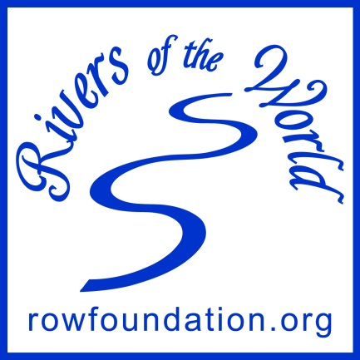
For Volunteer Badge, Please use the one below:

Frequently asked Questions (FAQs)
Can we get a few badges for the Leaders/coordinators?
Yes, I have given a few badges to the main coordinators in the past. In case they are not available, please print the attached badge in a small/badge size and attach it on your shirt pocket or arm-side by a pin.
How many people should we get?
15-30 people should be fine, but less than that is okay too.
Should we contact or invite local newspaper? Do you want this event to be on paper or not ?
Sure, local Newspaper or media can be contacted. In the past I have sent special messages to the participants in a letter form (Agra), which was published in the local Newspaper and it got attention of many volunteers and they had a great turnout. You can arrange something similar. I can send the letter with a special message for your location/event if you need one.
Should we print T-shirts ? I have come across a logo in the website given by you.
You don’t have to go for T-shirts, just print the Patches and give those to wear with safety-pins or clips
I am also planning to print few posters from the campaign materials from the UN website and give those to some student participants.
PLEASE USE THIS GENERAL BANNER WITH YOUR LOCAL EMAIL ETC.
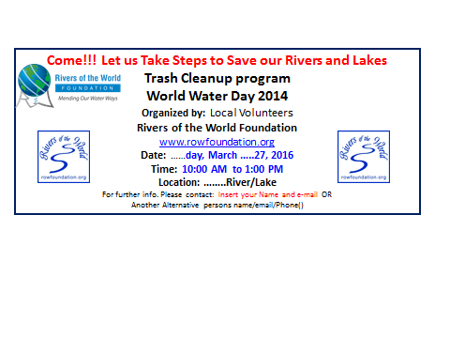

This Year’s UN World Water Day theme is “Water and Jobs”
Please check back the website (http://rowfoundation.org )for UPDATED INFORMATION under
Banners and Logos (http://rowfoundation.org/0/WWD-2016-Banners-Logos.doc )
The Rivers of the World (ROW) Foundation (http://rowfoundation.org ) is conducting trash cleanup and other awareness activities tentatively planned for the following sites. For exact timing, locations, and other information please contact the cleanup coordinators below.
- INDIA (IN), Agra, Yamuna River
Shravan Kumar (sinshravan@gmail.com), Brij Khandelwal (agrabrij@gmail.com), Mrinal Agrawal (mgesgroup@gmail.com)

- Agra, Bamrauli Katara, MSK School, Yamuna River (IN)
Mr. Mahesh Mangalick (mmangalick@yahoo.com ), Mr. Pramesh Rana, Administrator, MSK School.

- Bangalore, Karnataka, India, Lake restorations (IN)
Mr. Sharadh Sindhia (sharadhsindhia@gmail.com )

- Bhuvaneswar, Odissa, India, Daya River (IN)
Mr. Prafulla Dhal (Prafulla.dhal@gmail.com),

- CHINA, Wuhan City, Yangtze River
Ms. Zhao Hong (494325542@qq.com )

- Gokul, UP, India, Yamuna River (IN)
Pawan Sharma, Mr. Ashwin Patel (ashwinjp@hotmail.com)

- Guwahati, Assam, India, Brahmaputra River (IN)
Mr. Gautam Lahkar (gautamlahkar@gmail.com ), and Paramita Chakravarty (paramitachakravarty@gmail.com)

- Ghansali, Uttarakhand, India (Himalayan English School) (IN)
Mr. Sudhir Nautiyal (sudhir_nautiyal@yahoo.co.uk )

- Kolkata, India, Hooghly River (IN)
Mr. Sucharit Dutta (sucharit2011@gmail.com), & Mr. Sudip Homechoudhury (sudiphom@gmail.com )

- Mysore, Karnataka, India, Lake restorations (IN)
Dr. Sadashiva Murthy (bmsada@gmail.com) Ms. Roopa Shekar (roopa.setty1@gmail.com )

- NEPAL, Kathmandu/Nuwakot , Local Stream/Bagmati River restoration
Mr. Bishnu Prasad Adhikari, (Bishnuagaman@gmail.com )

- PHILIPPINES, ILOILO City, Iloilo River
Mr. Noel Hechanova (noel_hechanova@yahoo.com), Dr. Evelyn Belleza (etbelleza8@yahoo.com )

- Rishikesh,: Uttarkhand, India, Ganges River (IN)
Swami Amritarupananda (amritarupananda78@yahoo.com ), and Mr. Sudhir Nautiyal (sudhir_nautiyal@yahoo.co.uk )

- Roorkee, Uttarakhand, India, Solani River (IN)
Dr. OmPrakash Dube (opdubey11@gmail.com ), Mr. Siddhartha Khare, PhD Scholar, IIT Roorkee, ( siddhartha.khare@gmail.com )

- Benekhali, West Bengal, India, Vairab River (IN)
Ashok Saha (local), Indrajeet Sen (sen.indrajeet@gmail.com )

- Vizianagaram, Andhra Pradesh, India, Lake restoration/awareness (IN)
Dr. Tata Prakasam ( prakasamtata@gmail.com), and Dibyatanay Joardar ( djoardar92@gmail.com )

- USA , Washington, DC, Potomac River Cleanup/Lake restoration/awareness
Subijoy Dutta ( Subijoy@verizon.net ), and Dick Lahn ( dicklahn@gmail.com )

The UNEP officials in Washington, DC have met with us and have officially communicated a collaborative effort with the Rivers of the World Foundation for the World Water Day campaign.
Some of the exciting features of this year’s programs are –
- The Bhilangna River awareness activities, including water testing by the students and teachers of the Himalayan English School, Ghansali, Uttarakhand, India.
- The Solani River trash cleanup effort by the graduate students of IIT Roorkee and local communities in Roorkee, Uttarakhand, India.
- Yangtze River Trash Cleanup Effort, Wuhan City, China – a massive awareness effort involving children, youths, adults, aged and all others in the community to turn this into a common practice.
- Iloilo River, Philippines – Youth Forum, River tour and many other activities for a week-long celebration of World Water Day 2016. Mr. Noel Hechanova, Director, ENRO, and Dr. Evelyn Belleza, Vice Chancellor, P&D, Univ. of Western Visayas, Ililo, Philippines indicated their plan.
- Daya River, Bhubaneswar, Odisha, India – Because of the high awareness and local support due to a successful seminar arranged by Mr. Prafulla Dhal last January, a big event centering the WWD2016 is planned by the local NGOs and communities in coordination with Prafulla Dhal representing ROW Foundation.
- Yamuna River, special event by MSK School in Bamrauli Katara, Agra, coordinated by Mr. Mahesh Mangalick, Founder, School and Village Development.
- Other Rivers, such as the Brahmaputra River, Vairabh River, Hooghly River, Ganges River and Local Stream/River in Nepal is also being planned this year.
Plastic Bags will be used by the Volunteers to collect recyclable items, and trash to be disposed. The recyclables will be transported to the municipal recycling centers when available; arrangements are being made for the trash to be picked up by the city garbage collection system, where feasible.
After the Trash Cleanups, reports on the amount of trash (or number of trash bags and their sizes), the pictures from the activities, and a short list of volunteers are expected from the coordinators from each of these events. This information will be released publicly about how much volume/weight and types (paper, plastics, soda cans, bulk items, such as tires etc.) of trash collected. The Rivers of the World Foundation will have listing of volunteers and pictures from the Cleanups, as submitted by the coordinators, on the websites, which should be easily accessible to everyone. For exact timing, locations, and other information please contact the cleanup coordinators listed above.
Primary Contact for All Rivers of the World Events are listed below:
Contact: Subijoy Dutta , Washington, DC area, USA (subijoy at Verizon dot net) or Sucharit Dutta, Kolkata, India (sucharit2011@gmail.com )

